101 E CROSSROADS PKWY SUITE A
BOLINGBROOK IL 60440
OFFICE: (630) 296-6080
INFO@ORANGECABIENTRY.COM
WWW.ORANGECABINETRY.COM

SPECIAL INSTRUCTIONS:

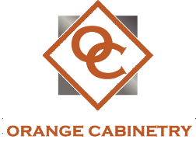
OC- PRODUCT ORDER FORM

USE DROPDOWN SELECTIONS TO COMPLETE YOUR ORDER
ORDER DATE:
ORDER NO:
SALESPERSON:
PICKUP/ DELIVERY:
DELIVERY ADDRESS:
CITY, STATE, ZIP:
*APPLICABLE TAX WILL BE ADDED WHEN ORDER IS COMPLETED!

STYLE | CATEGORY | PRODUCT | DEALER PRICE | QTY | HINGER L/R | TOTAL
 |  | *PRODUCT TOTAL:

